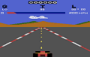
Z26 is one of the best emulators for the Atari 2600. The author reports that the graphics part of the emulator is nearing perfection to a point that there's little more to fix.

